Product and Engineering

Product Essentials Program

This is to certify that

# **Buni Saraswati**

has successfully

completed the Highway to HighRadius Internship Program from 28th January 2022 to 13th April 2022, where he/she built and deployed an AI Enabled Fintech B2B Cloud Application.

**Anushna Bora**

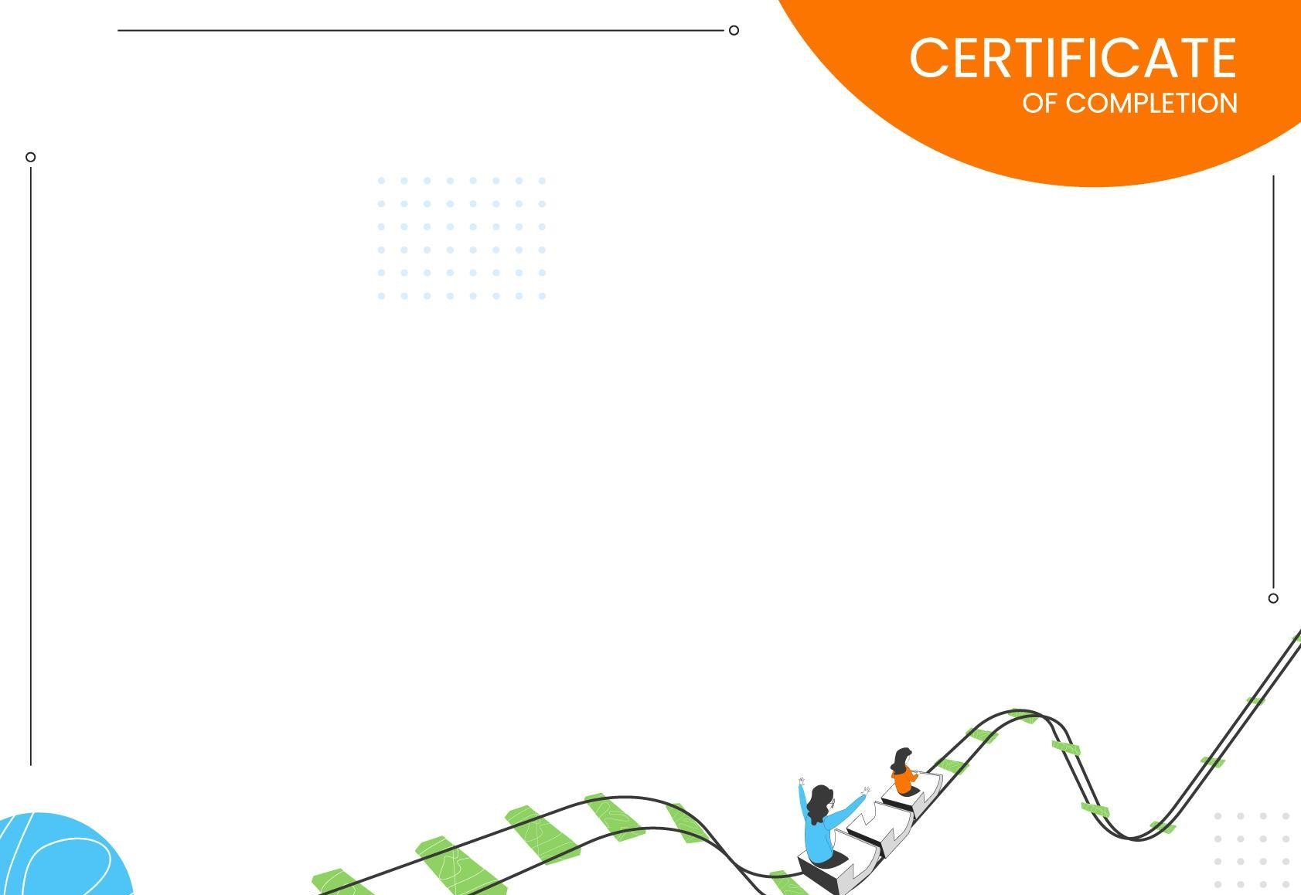

During this project, he/she was involved in creating a full stack web-based product thereby developing a deep understanding of all aspects of product development such as identifying appropriate user

requirements, designing a great user experience and building appropriate data models and machine learning models along with relevant

UI components and backend design.

Neha Srivastava

AVP, People & Culture HighRadius